[15/07/2016] - 7th European Summit of Regions and Cities
ACR+ presented LIFE FUTURE and other of its public procurement projects in Bratislava in July 2016
ACR+ took part in the 7th European Summit of Regions and Cities held on 8 and 9 July 2016 in Bratislava. This event, organised by the Committee of the Regions, Bratislava municipality and Bratislava region focused on the need for investments and for better cross-border connections in order to unlock the growth potential offered by the rich diversity of Europe's regions. During the session "Investment in Motion" ACR+ made a video presentation about the activities of the Circular Europe Network, the PPI4Waste project on public procurement of innovation in the field of waste management and resource efficiency, and on the LIFE Future project about green public procurement for urban furniture.
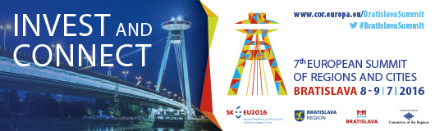
External link: http://www.cor.europa.eu/bratislavasummit/

